Diagram of the Skin

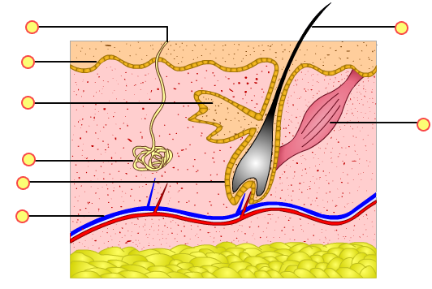

Epidermis

Pore

Blood vessels

Hair Follicle

Sweat Gland

Oil Gland

Dermis

Muscles

Hair Shaft