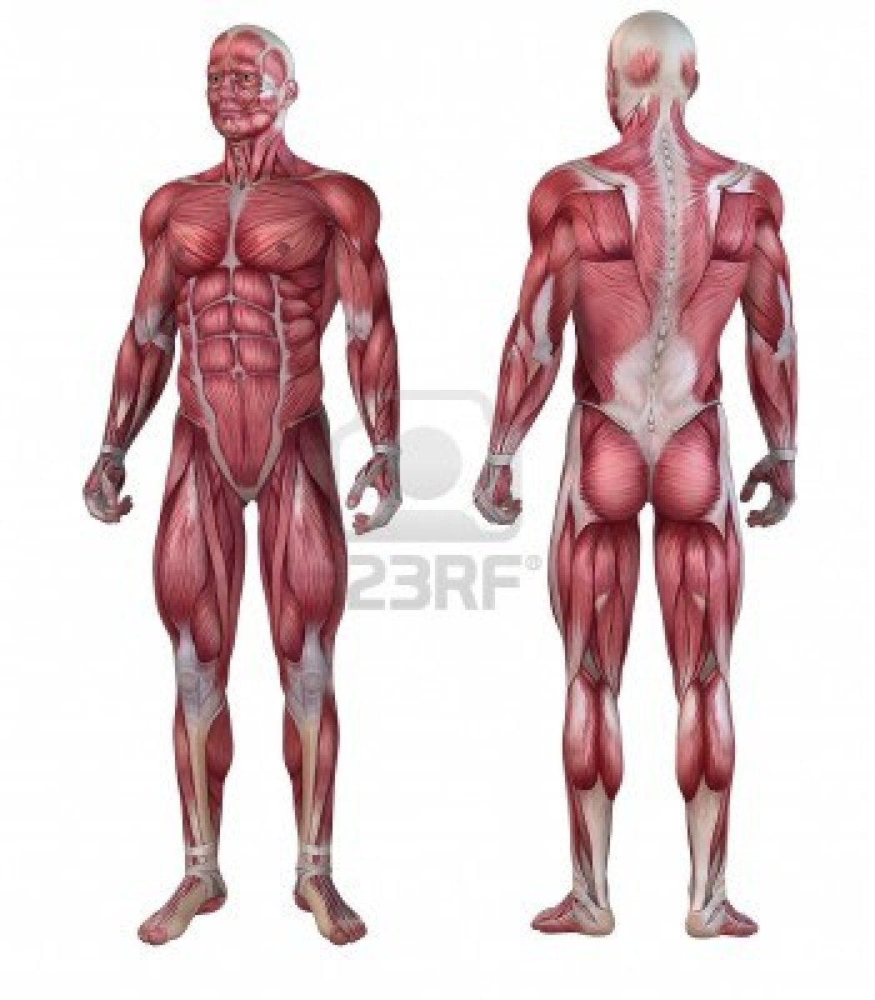

8

7

5

6

4

3

1

2

The Muscular System