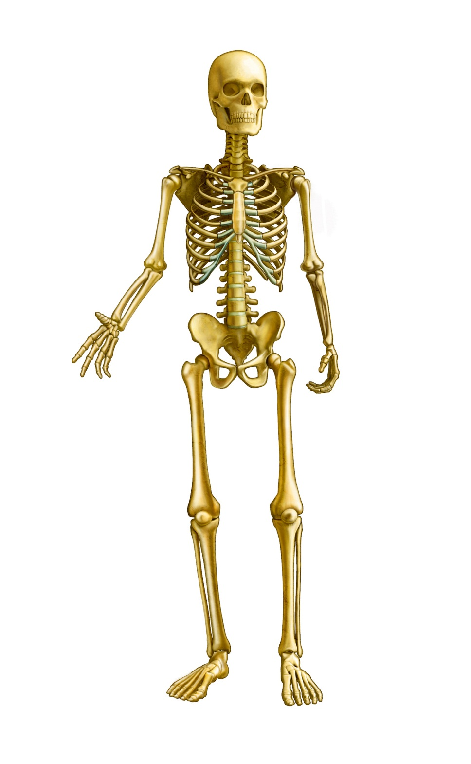

9

7

6

8

5

3

4

2

1

Skeletal System